**Subject : Software Engineering**

**Subject Code : CS3273**

**Section: Gx**

**Topic : Different Phases Of Software**

**Development Lifecycle case study**

|  |  |
| --- | --- |
| **Enrollment no.** | **Name** |
| **2020CSB007** | **ARATRIKA PAL** |
| **2020CSB009** | **MAYANK MANAVENDRA KUMAR** |
| **2020CSB010** | **GOURAV KUMAR SHAW** |
| **2020CSB011** | **TAMOGHNA ROY** |
| **2020CSB013** | **ABDUL KHAZMUDDIN** |
| **2020CSB014** | **SIDDARTHA JANA** |

**Part II: 2 weeks**

**Hence briefly describe your collected samples in form of a case studies (word limit for each**

**sample:100). Since you are guaranteed to come up with many pieces of text, figures, tables,**

**notations etc. in discrete form, you are advised to submit a single doc/pdf file for this entire**

**assignment. In your descriptions don’t forget to refer your sources (url/book/journal/conference etc.) of the samples.**

**1.Case Study for Fire Alarm App:**

* **Feasibility Analysis for Fire Alarm App:**

1. **Technical Feasibility:** Determine if the necessary technology exists to build the fire alarm app, including hardware and software requirements, and assess the app's compatibility with existing systems.
2. **Operational Feasibility**: Evaluate if the fire alarm app can be integrated into existing fire safety procedures and if it can provide value to users in terms of improving response time and reducing fire-related incidents.
3. **Economic Feasibility:** Assess the cost-effectiveness of the fire alarm app, including development costs, maintenance costs, and potential return on investment.
4. **Schedule Feasibility:** Determine if the development timeline is realistic and if the project can be completed within the given constraints.
5. **Legal and Regulatory Feasibility:** Review relevant laws and regulations related to fire safety and ensure that the fire alarm app complies with all necessary standards.

By conducting a thorough feasibility analysis, stakeholders can determine if the fire alarm app is viable, what resources will be required, and if it can provide the desired benefits. This information can inform decision-making and help ensure the success of the project.

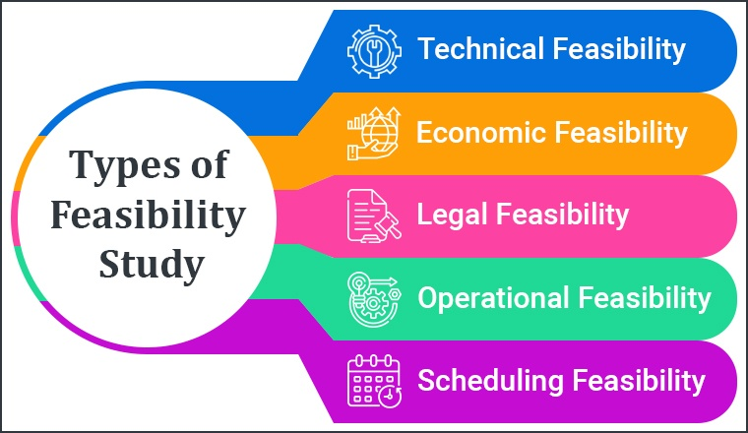

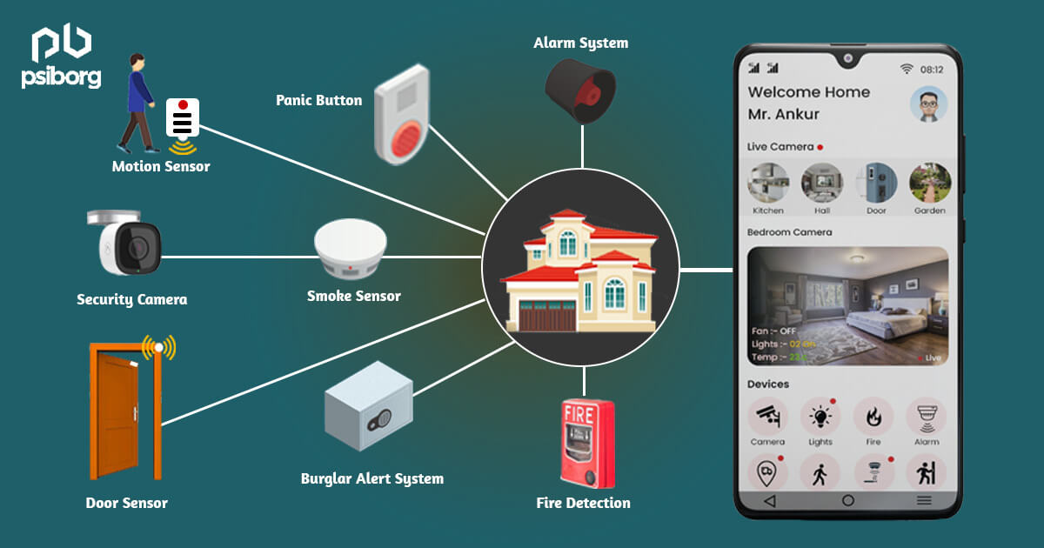

* **Requirement Analysis for Fire Alarm App:**

1. **User Requirements:** Identify the needs and expectations of users, including fire departments, building owners, and occupants. This may include features such as real-time notification, location-based alerts, and automatic reporting to the fire department.
2. **Functional Requirements:** Specify the required functions of the fire alarm app, including the ability to detect fires, alert users, and provide real-time updates on the status of a fire.
3. **Non-Functional Requirements:** Identify requirements related to the app's performance, such as response time, reliability, and security. This may include requirements for data encryption, secure storage of user information, and availability during an emergency.
4. **Technical Requirements:** Define the technical specifications for the fire alarm app, including hardware and software requirements, compatibility with existing systems, and performance requirements.
5. **Legal and Regulatory Requirements:** Ensure that the fire alarm app complies with all relevant fire safety regulations and standards, including requirements for fire alarm systems, reporting, and data privacy.

By thoroughly analyzing the requirements, stakeholders can ensure that the fire alarm app meets the needs of users, provides the desired functionality, and complies with necessary regulations. This information can inform the design and development of the app, as well as ensure its successful deployment and use.

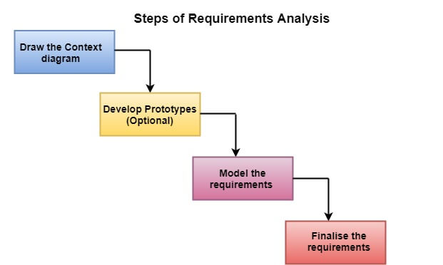

* **Design for Fire Alarm App:**

1. **User Interface Design:** Design an intuitive and user-friendly interface for the fire alarm app, including a clear and simple layout, easy navigation, and an emergency alert system.
2. **Architecture Design:** Determine the architecture of the fire alarm app, including the components, modules, and relationships between them. Consider factors such as scalability, performance, and security in the design.
3. **Database Design:** Design a database to store data related to fires, including location information, time of the fire, and status updates. Ensure that the database is secure and can be easily accessed by authorized users.
4. **Notification Design:** Design a notification system that can alert users in real-time in the event of a fire. Consider factors such as reachability, reliability, and urgency in the design.
5. **Integration Design:** Design the fire alarm app to integrate with existing fire safety systems, such as fire alarms and sprinkler systems, to provide a comprehensive solution for fire safety.

By designing the fire alarm app in a clear and intuitive manner, stakeholders can ensure that it is easy for users to use and provides the necessary functionality during an emergency. The design should also consider factors such as scalability, performance, security, and integration with existing systems to ensure the success of the app.

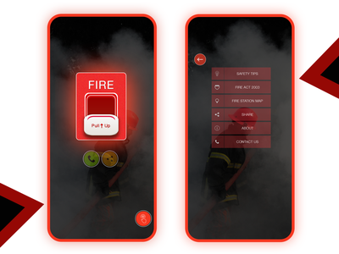

* **Coding Phase for Fire Alarm App:**

1. **Coding Standards:** Adhere to established coding standards and best practices to ensure the quality and maintainability of the code.
2. **Development Environment:** Set up a development environment that is appropriate for the fire alarm app, including tools and libraries, and ensure that all necessary software and hardware are in place.
3. **Coding:** Write the code for the fire alarm app, implementing the user interface, database, notification system, and other components as designed.
4. **Testing:** Conduct unit testing and integration testing as the code is written to ensure that it is working as expected. This can include functional testing, performance testing, and security testing.
5. **Debugging:** Debug any issues found during testing and fix any bugs that are identified.
6. **Documentation:** Document the code and the development process, including any design decisions, code reviews, and testing results, to facilitate maintenance and future updates.

In the coding phase, the fire alarm app is brought to life by writing the code and implementing the design. This phase involves a combination of writing code, testing, and debugging, and is an important part of ensuring the quality and functionality of the app. It is also important to document the code and development process to facilitate maintenance and future updates.

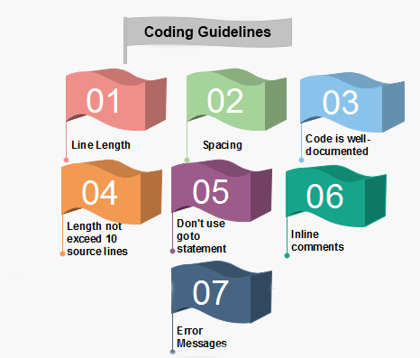

* **Software testing Phase for Fire Alarm App:**

1. **Test Planning:** Develop a comprehensive test plan that outlines the testing strategy, testing objectives, test cases, and testing environment.
2. **Test Environment:** Set up a test environment that mimics the production environment as closely as possible to ensure accurate testing.
3. **Test Execution:** Execute the test cases, including functional testing, performance testing, security testing, and user acceptance testing, to verify that the fire alarm app meets the requirements and works as expected.
4. **Test Reporting:** Document the results of the testing, including any issues found, and report on the status of the testing process.
5. **Defect Tracking:** Track and manage any defects or issues found during testing, prioritizing them based on their severity and impact on the app's functionality.
6. **Regression Testing:** Conduct regression testing to ensure that fixes or changes made to the code do not impact other parts of the app.

The testing phase is a critical part of the software development life cycle, as it is where the fire alarm app is put through its paces to ensure that it works as expected and meets the requirements. This phase involves a combination of manual and automated testing, and is an important step in ensuring the quality, performance, and security of the app before it is deployed to users.

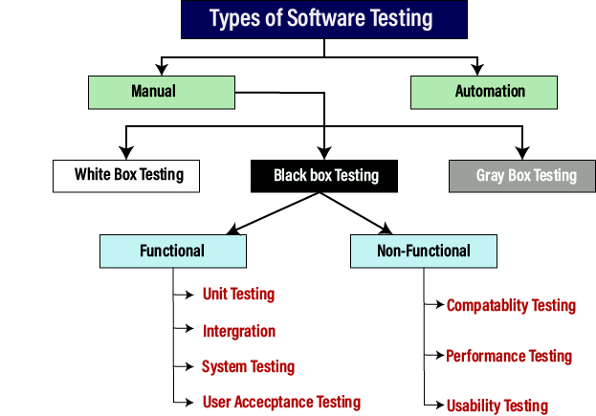

* **Software Maintenance for Fire Alarm App:**

1. **Bug Fixes:** Address and fix any bugs that are reported by users or discovered during routine monitoring.
2. **Security Updates:** Apply security updates and patches to ensure that the fire alarm app remains secure and protected against potential threats.
3. **Performance Optimization:** Optimize the performance of the fire alarm app to ensure that it runs smoothly and efficiently.
4. **New Feature Implementation:** Implement new features and functionality based on user feedback and changing requirements.
5. **Documentation Updates**: Update the documentation to reflect any changes made to the fire alarm app, including bug fixes, new features, and security updates.
6. **Monitoring:** Monitor the fire alarm app to identify any potential issues and to ensure that it is working as expected.

Software maintenance is an ongoing process that is critical to the success and sustainability of a fire alarm app. It involves fixing bugs, applying security updates, optimizing performance, and implementing new features to ensure that the app continues to meet the needs of its users. Regular monitoring is also important to identify and address any potential issues as they arise.

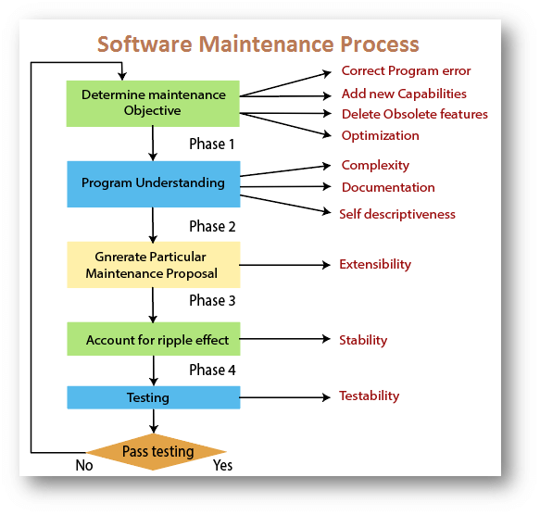

References:

1. https://www.thestudygenius.com/sdlc-software-development-life-cycle/
2. <https://www.geeksforgeeks.org/types-of-feasibility-study-in-software-project-development/>
3. <https://www.tutorialspoint.com/system_analysis_and_design/system_analysis_and_design_development_life_cycle.htm>